**Name: Tejas Nalawade Roll No: TCOD 01**

**Assignment 01**

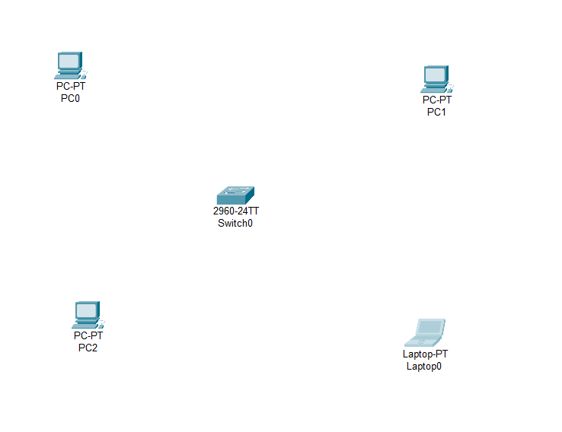Setup a wired LAN using Layer 2 Switch. It includes preparation of cable, testing of cable using line tester, configuration machine using IP addresses, testing using PING utility and demonstrating the PING packets captured traces using Wireshark Packet Analyzer Tool.

